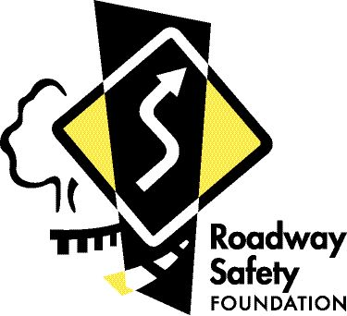
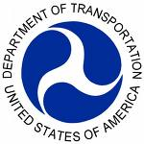

FHWA XX-17
Wednesday, November 15, 2017

Contact: Doug Hecox
Federal Highway Administration
1200 New Jersey Avenue, SE
Washington, DC 20590
Tel: 202-366-0660
https://www.fhwa.dot.gov/briefingroom/

Contact: Lon Anderson
Roadway Safety Foundation
1920 L Street NW, Suite 525
Washington, DC 20036
Tel: 202-679-4020
www.roadwaysafety.org
Follow us on Twitter: @USDOTFHWA

‘National Roadway Safety Award’ Winners Announced
FHWA, Roadway Safety Foundation officials name nation’s top nine road safety projects

WASHINGTON – The Federal Highway Administration (FHWA) and the Roadway Safety Foundation today announced the year’s nine National Roadway Safety Award winners, which represent the nation’s best examples of innovation in highway safety. The biennial competition, which began in 1999, is an acknowledgement of successful approaches to improving roadway safety at the state and local level, officials said.

“These awards recognize real and innovative solutions to some of the nation’s biggest safety challenges,” said Acting Federal Highway Administrator Brandye L. Hendrickson. “We commend this year’s winners for their efforts in saving lives on our nation’s roads, and invite others across the country to put these life-saving solutions to work.”

Applicants are encouraged to nominate projects or programs that exemplify innovative and effective safety activities and maximize the cost effectiveness of federal, state, local, and/or private sector funds.

“The National Roadway Safety Awards are an opportunity to recognize the unsung heroes who plan, engineer and implement creative measures to help save lives on a daily basis and rarely receive credit for doing so,” said RSF Executive Director Gregory Cohen.

Of the 32 applications this year, nine winners were selected:

Alaska – for its efforts to blend engineering, enforcement, education and emergency response in “Safety Zones” which led to a 45 percent reduction in fatal and serious injury crashes on high-speed two-lane roads over the last decade.

Delaware – for using cutting-edge “high-friction surface treatment” to improve traction at key spots, Delaware transportation officials reduced roadway departure crashes by 56 percent.

Florida – for using a variety of state-of-the-art engineering countermeasures, public education and law enforcement efforts, to address a recent surge in wrong-way driving incidents.

Michigan – for its new multi-agency Traffic Incident Management partnership to improve safety for first responders and tow truck operators, which led to a 31 percent reduction in tow truck response time and a 45 percent reduction in secondary crashes.

Minnesota – for developing County Road Safety Plans for all 87 counties statewide which used low-cost solutions to address problems on county roads, which account for half of all roadway fatalities, over a four-year period.

Missouri – for committing itself to achieving zero roadway fatalities with a decade-long series of road improvements at 31 high-crash locations statewide.

New Jersey – for installing a roundabout at a high-crash intersection in Chesterfield Township, eliminating all right-angle and left-turn crashes over the last three years, and planning others statewide.

Virginia – for addressing an increase in crashes at a two-way intersection in Loudoun County with an “instant roundabout” system, which cost 95 percent less than a traditional roundabout and reduced crashes by 89 percent over a three-year period.

Tennessee – for using greater data analysis of 261 crash locations statewide to maximize safety investments, which led to a 60 percent reduction in crash frequency over three years.
Winners were selected by an expert panel of judges from a variety of disciplines. This year's judges included:
- King W. Gee, director of engineering and technical services, American Association of State Highway and Transportation Officials
- Mike Griffith, director, FHWA’s Office of Safety Technologies
- Bruce Hamilton, director of safety and research programs, Roadway Safety Foundation
- Bernardo Kleiner, senior program officer/transportation safety specialist, Transportation Research Board
- Jennifer Smith, director, Image and Brands, Michelin
- Dr. Marie B. Walsh, director, Louisiana Local Technical Assistance Program (LTAP)
- Terecia Wilson, senior fellow, Clemson University Institute for Global Road Safety and Security.
For complete details on each of the winners, and for more information on the national awards program, visit http://www.safety.fhwa.dot.gov/roadwaysafetyawards/.
# # #
The Roadway Safety Foundation is a 501(c) (3) charitable and educational organization. Our mission is to reduce the frequency and severity of motor vehicle crashes, injuries, and fatalities through improvements to roadway systems and their environment.

